Project Design Phase
Solution Architecture
Date | 24 September 2026
Team ID | SWTID-2026-7356
Project Name | AI StudyBuddy
Maximum Marks | 4 Marks

Solution Architecture:
Solution architecture connects the student's learning problems with a suitable technical solution. For AI StudyBuddy, it does the following:
- Technology choice: Uses Node.js, Express.js, MongoDB with Mongoose, and Google Gemini 2.5 Flash to solve students' revision problems.
- System structure: Shows how the client, Express server, authentication middleware, controllers, AI service and database work together.
- Functional components: Covers registration and login, study-material upload and storage, summaries, flashcards, quizzes, personalised study plans and admin management.
- Technical specification: Gives a clear base for building a secure, modular and extendable AI learning API, with JWT tokens, bcrypt password hashing and student / admin roles.

Example – Solution Architecture Diagram:
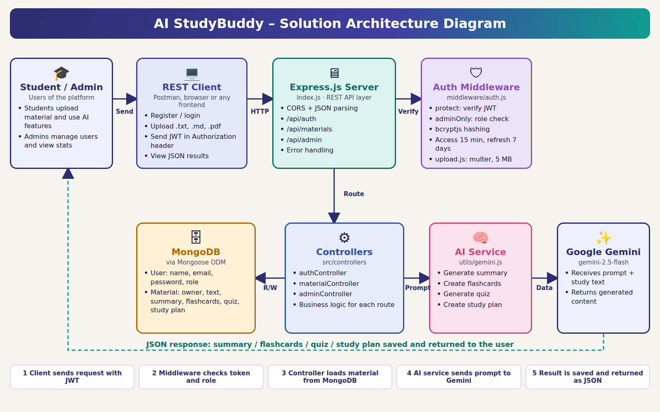
A client sends a request with a JWT token. The middleware checks the token and role, and the controller loads the student's material from MongoDB. The AI service sends a prompt to Gemini, and the generated result is saved and returned as JSON.

